**QUESTIONS**

**What are three conclusions that we can draw about crowdfunding campaigns?**

1. In crowdfunding analysis, on basis of per category, the highest number of successful campaigns is for theater for almost all the country maybe because of its reach to more people (high customer reach) followed by film & video whereas journalism being lowest. But theater also has more number failed and canceled campaigns. Still the count for theater in successful campaign is more than failed.

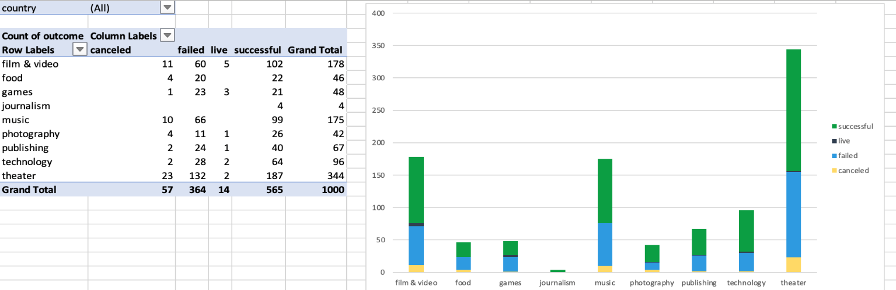

1. In crowdfunding analysis, on the basis of sub category, plays has highest number of success which is under parent category of theater and the lowest number is for audio, radio and world music. We also got the total number of successful, failed, canceled and live campaigns. Successful campaigns have highest count of 565 and live campaign being the lowest. Thus, it can be concluded that entertainment (theater) gives more successful campaigns.

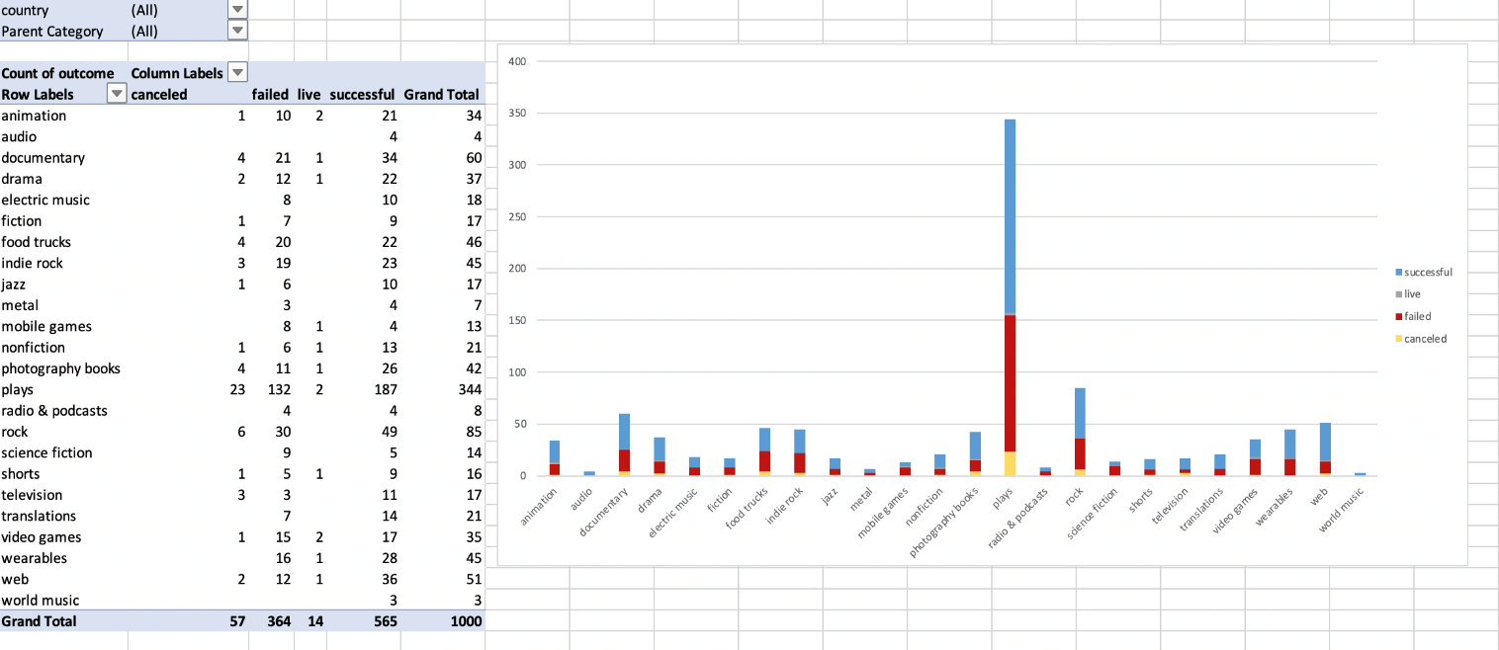

1. In crowdfunding analysis, on basis of month analysis, start from May it started increasing and in July it has maximum number of successful campaigns whereas, August has less successful campaigns which makes month August peak of failed campaigns. Also, theater is at peak around June-July month maybe because of summer vacation and weather conditions.

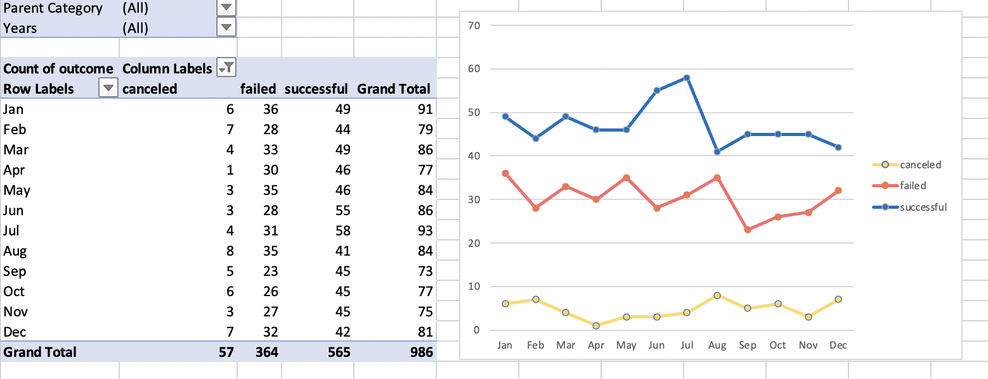

**Some limitations of this dataset?**

1. The dataset/sample is not large enough (just 1000) to conclude any significant result. We need bigger sample size to have significant differences in different categories.
2. Missing new dataset for 2021-22.
3. Other types of charts and graphs should also be used other than bar chart (mostly used).
4. Live campaigns data missing from line graph of month and campaign outcome

**Other possible tables and/or graphs that we could create, and what additional value would they provide?**

1. Some correlation tables or graphs for goals and pledged for country wise.
2. Country comparison table for successful or failed campaigns.
3. Tables or graphs including average donation with the outcomes.
4. Live campaigns data missing from line graph of month and campaign outcome.

**STATISTICAL ANALYSIS QUESTION:**

**Use your data to determine whether the mean or the median better summarizes the data.**

The mean for successful campaigns is 851.14 and median is 201 which is relatively less than mean. The difference between the value of mean and median results that it is right-skewed distribution. The minimum value is 16 whereas maximum value of backers is 7295 which shows the wide range of variation for successful campaign, whereas, the mean for failed campaigns is 585.61 and median is 114.5 which is also less than mean and has right-skewed distribution. Minimum value of backers for failed campaigns is 0 and maximum value of backers is 6080 which again has wide range od difference just like successful campaign.

Therefore, **Median** better summarizes the data in both successful and failed campaigns because distribution in both data sets have outliers or are skewed and median is more unaffected to it than mean since mean value do change due to outliers.

**Use your data to determine if there is more variability with successful or unsuccessful campaigns. Does this make sense? Why or why not?**

The Variance and standard deviation for number of backers in successful campaign is 1603373.732 and 1266.24 respectively whereas variance and standard deviation for failed campaign is 921574.6817 and 959.98 respectively. These measures of variability clearly shows that Successful campaign has much more variability than failed campaign. This totally make sense because the range of minimum and maximum number of backers for successful campaign (7295-16 = 7279) is more than failed campaign (6080-0 = 6080) and also in failed campaign backers count is 0 or very low in multiple cases. Thus, high numbers of backers count (from 16 to 7295) in successful campaign also led to its success along with the significant variability.

|  |  |  |
| --- | --- | --- |
| **SUCCESSFUL CAMPAIGNS** |  | **UNSUCCESSFUL(FAILED) CAMPAIGNS** |
| Mean number of backers = 851.14 |  | Mean number of backers = 585.61 |
| Median number of backers = 201 |  | Median number of backers = 114.5 |
| Minimum number of backers = 16 |  | Minimum number of backers = 0 |
| Maximum number of backers = 7295 |  | Maximum number of backers = 6080 |
| Variance of the number of backers = 1603373.732 |  | Variance of the number of backers = 921574.6817 |
| Standard Deviation of number of backers = 1266.24 |  | Standard Deviation of number of backers = 959.98 |

|  |
| --- |
| **`** |
|  |
|  |
|  |
|  |
|  |
|  |